PDS Project – Car Rental   
[gss399@nyu.edu](mailto:gss399@nyu.edu)  
gss399

Project Description – A car rental company CRC provides services like renting a car to the customer depending on the car type, location and the number of hours to rent a particular car. The company wants to develop a relational database to monitor it’s customers, car types, rentals and the locations.

Tables:

**Car**  
Field Description

carID A unique ID assigned to each car.  
currentLocationID The current location Id for the car depending on its current location  
typeID The type of the car to which it belongs to, acts as foreign key here.  
brand The brand of the car   
model The model of the car  
color The color of the car  
purchDate The purchase date of the car

**Car_type**  
Field Description

typeID A unique type for each car to which it belongs.  
typeLabel A label for each like Sedan, SUV, Truck, etc.  
typeDecsr A detailed description for the type of the car.

**Customer**  
Field Description

customerID A unique customer ID  
SSN The SSN of each customer  
firstName The first name of each customer  
lastName The last name of each customer.  
mobile The mobile number of the customer  
email The email of the customer  
state The state where the customer lives  
country The country where the customer lives  
  
**Reservation**  
Field Description

reservationID A unique reservation ID when a particular car is rented  
carID The car ID from the Car table  
customerID The customer ID from the customer table  
pickupLocationID The pickup location ID for the car  
returnLocationID The return location ID for the car  
pickupDate The pickup date for the car rented  
returnDate The return Date for the car rented  
amount The amount for the particular car to be rented

**CRC_Office**  
Field Description

locationID The location ID for the CRC office where it is located  
defaultTel The phone number of the office  
street The street location of the office  
number An alternative number for the office  
city The city where the office is located  
state The state where the office is located  
Country The country where the office is located

**Office_tel**  
defaultTel A default office number of the CRC rental services  
tel1 Alternative telephone number 1 of the CRC office depending on the location  
tel2 Alternative telephone number 2 of the CRC office depending on the location  
tel3 Alternative telephone number 3 of the CRC office depending on the location

The following sematic rules(real world) are adhered to the above database:

The carID of Car is unique  
The typeID of Car_type is unique  
The customerID of customer is unique  
The reservationID of reservation is unique  
The defaultTel of office_tel is unique  
The locationID of the CRC_office is unique  
A car may belong to exactly one type of car  
Customer can rent car from one location known as pickup location and drop off at another location known as return location

Foreign Keys

Car table:

* Car.currentLocationID references crc_office.locationID
* Car.typeID references car_type.typeID

Crc_office table:

* Crc_office.defaultTel references office_tel.defaultTel

Reservation table:

* Reservation.pickupLocationID references crc_office.locationID
* Reservation.customerID references customers.customerID
* Reservation.carID references car.carID

Database Diagram:

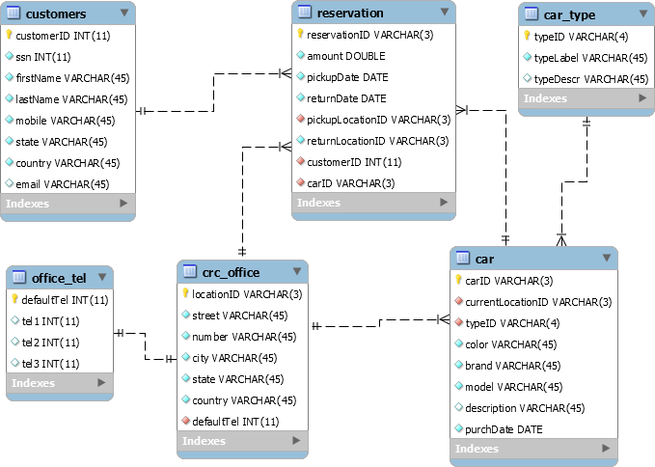

E-R Diagram:

SQL Create Statements:

Tables Data:

SQL Queries:

1. Show the first and the last name and the mobile phone number of those customers that have rented a car in the category that has label = ‘sedan’

1. Show the total amount of rentals per car's category ID and month.

1. For each rental’s state (pick up) show the top renting category.

